Accusation sheet
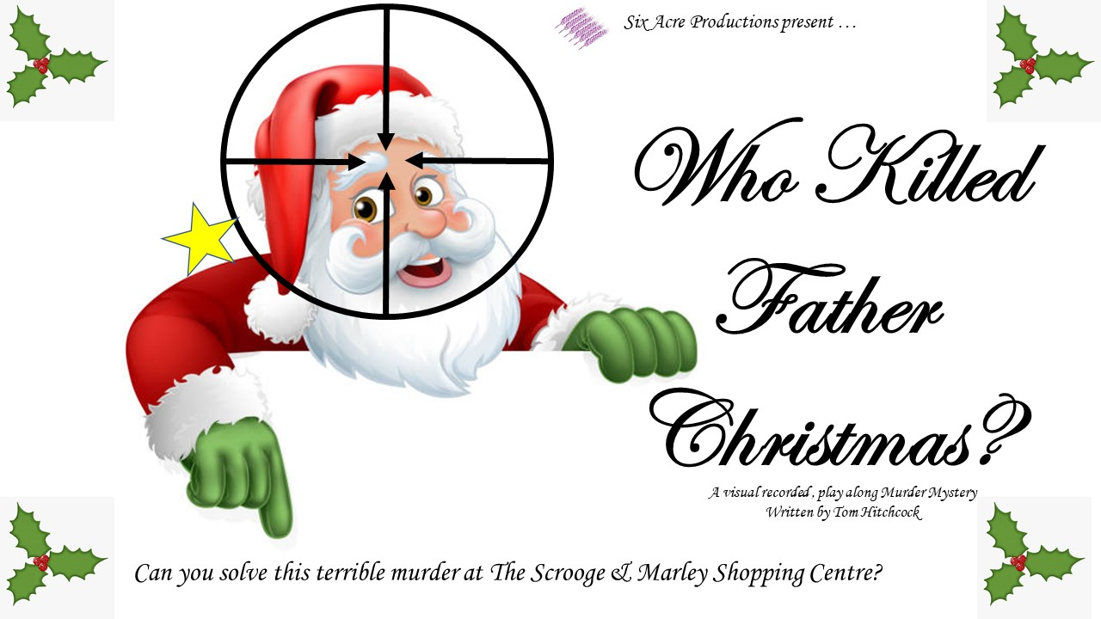
Team name
……………………………………………………………………………………………
We believe the murderer(s) to be …………………………………………………………………………………………………………………………………………………………………………………………………………………………………………………………………………………………………………………………………………………………………………………………………………………………………………………………………………………

And the Motive to be
…………………………………………………………………………………………………………………………………………………………………………………………………………………………………………………………………………………………………………………………………………………………………………………………………………………………………………………………………………………

